PRACTICAL MANUAL
Digital Forensics and Incident Response (DFIR)
Computer Forensics Virtual Lab (vLabs)

Submitted by: Vishal
Program: Master of Computer Applications (MCA)
Institute: LJ University, Ahmedabad

Source: https://cf-amrt.vlabs.ac.in

Practical 1: File Signatures and File Carving Techniques

Aim: To study file signatures (magic numbers) and use them to detect header corruption, carve a hidden file out of a host image, and reconstruct a file that was transferred across a network.

Theory
Every file format begins with a fixed sequence of bytes called a file signature or magic number, which lets an operating system or application identify the file's true type regardless of its extension. In digital forensics, signatures are used to detect files whose headers have been deliberately altered (header corruption), to carve embedded files out of a larger container such as a disk image, and to reconstruct files from fragments captured in network traffic. These techniques are widely used in evidence recovery, corrupted-data recovery, steganalysis, and network-traffic based investigations.

Pretect
What is the primary purpose of a file signature?
a: To provide a unique identifier for a file type
Which of the following file types is not commonly identified by its file signature?
a: .txt
In the context of file carving, what is the first step you should take when attempting to extract a file?
b: Identify the file signature
What is another common name for a file signature?
c: Magic number
Where is the file signature usually found within a file?
c: At the beginning of the file
Why might file signatures be more reliable than file extensions when identifying file types?
c: They are embedded in the file’s content

Simulation:
Header Corruption
- Selected the image (chipmunk photo) — original file signature: FF D8 (JPEG)
- Step-1: Modified the header bytes from FF D8 to DF D7 → image corrupted, no longer recognized as a valid JPEG
- Step-2: Entered the correct signature FF D8 and clicked Fix → image successfully restored
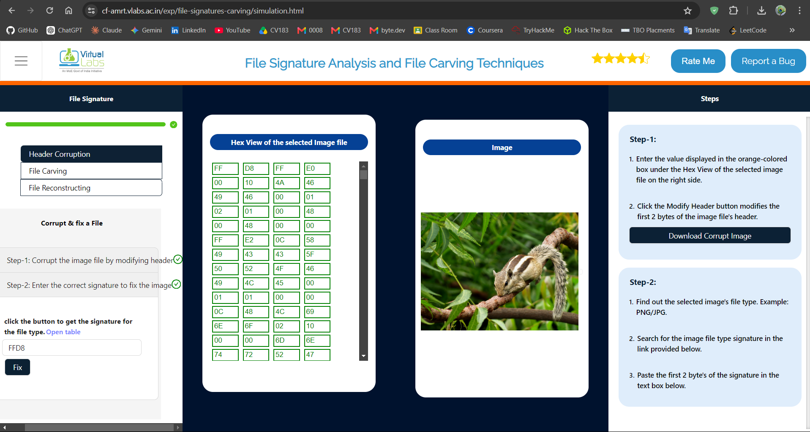
File Carving
- Entered the text Vishal to hide, ticked "Hide to Zip", clicked Hide → text embedded as a ZIP inside Image-2.jpg
- Entered the ZIP file signature 504B0304 and clicked Locate File → offset found: 00281138 (hex)
- Converted offset to decimal: 00281138 (hex) = 2625848 (decimal)
- Ran the command: dd if=Image-2.jpg of=hidden.zip bs=1 skip=2625848
hidden ZIP file successfully extracted (message: "Hidden File Extracted")
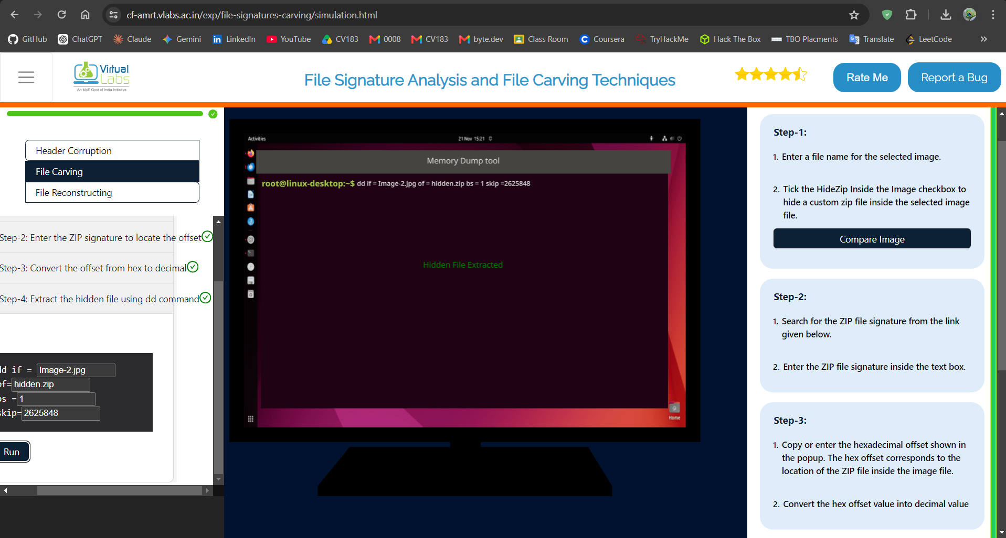
File Reconstruction (Network Capture)
- Selected file type .png, clicked Start Capturing, then Transfer
- In the VLabs Network Capture Tool, observed the FTP-DATA packet carrying the file (STOR putty.png, 14654 bytes) between 192.168.88.100 and 192.168.88.200
- Clicked "Reconstruct PNG file" → file successfully reconstructed from the captured packets
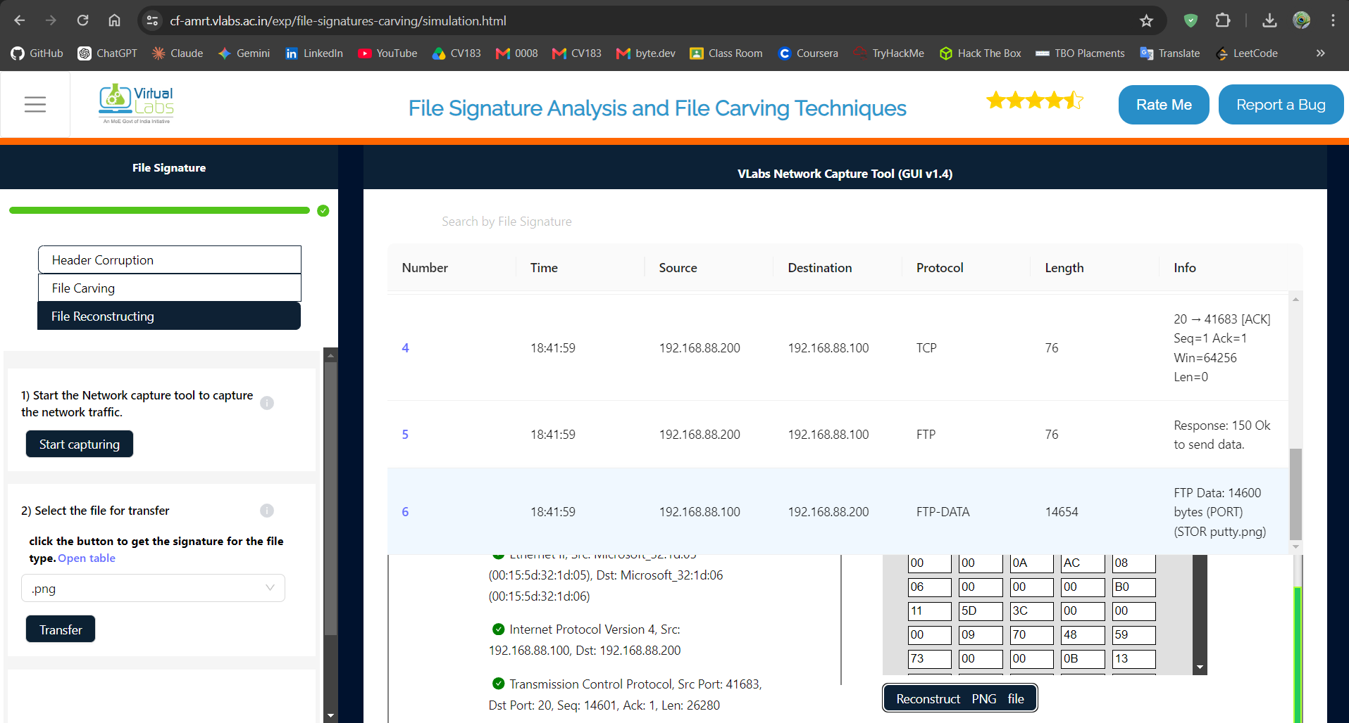

Posttest:
After identifying a file signature in a traffic dump, what is the next step in reconstructing the file?
b: Export the raw data bytes associated with the signature
When fixing a corrupted image header, why is it important to use the correct file signature?
a: The correct signature ensures that the file opens with the right application
In the context of file carving from an image file, what does the 'offset' refer to?
b: The location of the embedded file within the image
Which part of a file typically contains the file signature?
c: Header
What makes file signatures a reliable method for identifying file types?
b: They are embedded in every file and follow standard patterns
Which of the following is an example of a file signature for a PNG file?
c: 89 50 4E 47 0D 0A 1A 0A
Why is it important to know multiple file signatures for the same file format, such as JPEG and JPEG 2000?
a: Different versions of file formats use different signatures
In memory forensics, how are unique patterns constructed to identify memory-mapped files?
b: By analyzing the size and arrangement of operating system object structures
Which file signature would you expect when recovering a RAR-compressed file from raw storage?
a: 52 61 72 21 1A 07 00
Why is relying solely on file extensions insufficient when analyzing unknown files?
a: Extensions can be easily altered and may not match the file's true format
When recovering files from corrupted storage, why is it essential to analyze both headers and footers?
b: Because some file formats require matching start and end markers for accurate recovery

Conclusion:
All three sub-tasks were completed successfully — a corrupted JPEG header was identified and repaired, a hidden ZIP file was located and carved out of an image using its byte offset, and a PNG file was reconstructed from captured network traffic.

Practical 2: Memory Forensics: Retrieving Password Hashes and Cached Files

Aim
To perform memory forensics on a RAM dump — locating OS profile information, extracting SAM/SYSTEM registry hive offsets, dumping password hashes, and cracking a recovered hash.

Theory
RAM is volatile but, while a system is running, it holds artefacts that never touch disk — plaintext fragments, cached credentials and password hashes. Tools built on the Volatility framework parse a memory dump to identify the source operating system (imageinfo), locate the SAM and SYSTEM registry hives in memory, and extract the stored password hashes (hashdump). Because Windows never stores plaintext passwords, an examiner cracks the recovered NTLM/LM hash offline to recover the actual password. This is central to incident response and credential-theft investigations.

Pretest:
What is a Volatility Framework? It is a ?
b: Memory analysis too
Is there a possibility to extract files from RAM?
a: yes
Do you know if Windows registry caches the hashed passwords in its hives?
a: yes
What is typically stored in RAM during system operation?
a: Files currently being used
What is a memory dump?
b: A copy of data stored in RAM
Which of the following is a common use of memory forensics?
b: Recovering active session data
Simulation:
Retrieving Account
- Created the memory.dump file using the MemoryDump tool and transferred it to the forensic system.
- Analysed the memory dump using Volatility imageinfo and identified the OS profile as Win7SP1x64.
- Listed the Windows Registry hives using hivelist and identified the SYSTEM hive at 0xfffff8a000022010 and SAM hive at 0xfffff8a0016a7420.
- Extracted the password hash using hashdump with the SYSTEM and SAM offsets. The hash obtained for GuestUser was 5f4dcc3b5aa765d61d8327deb882cf99.
- Entered the extracted hash into the hash-cracking tool → password successfully recovered as HOWAREYOU.

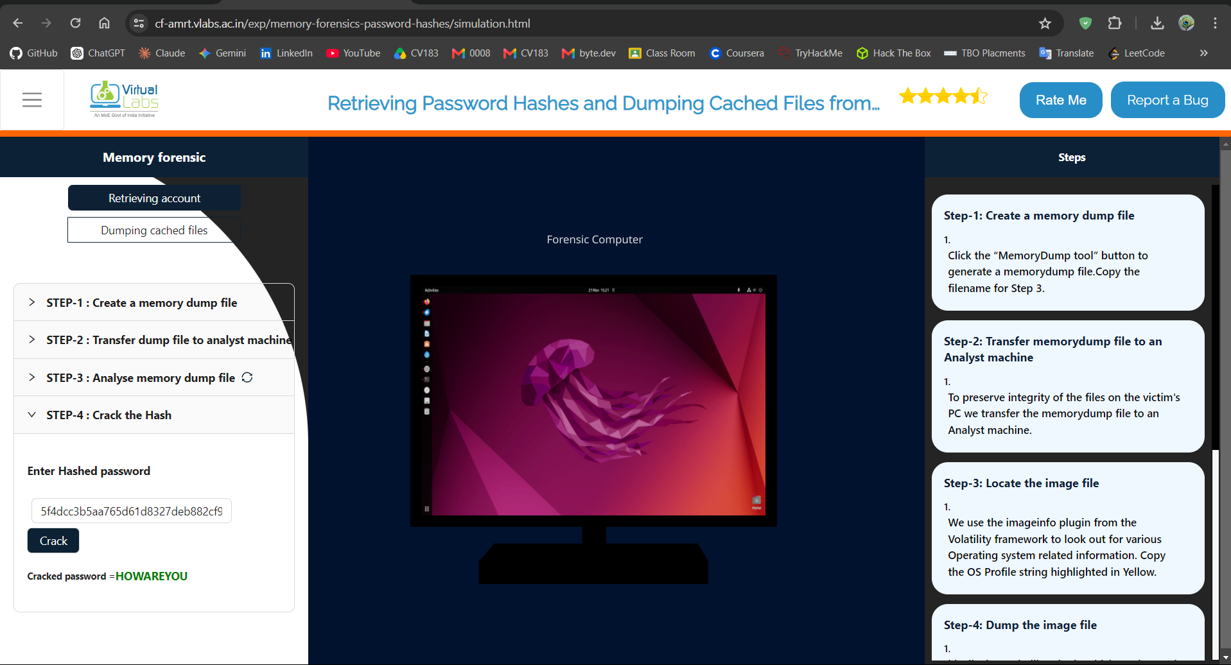

Dumping Cached Files
- Analysed the memory.dump file using Volatility imageinfo and identified the profile as Win7SP1x64.
- Used the filescan command to locate the cached image file C:\config\nature.jpg in the memory dump.
- Identified the file's physical offset as 0x0000000004a41433.
- Ran the dumpfiles command with the identified offset to extract the image file to /opt/.
- Opened the extracted file successfully and viewed the recovered nature.jpg image.
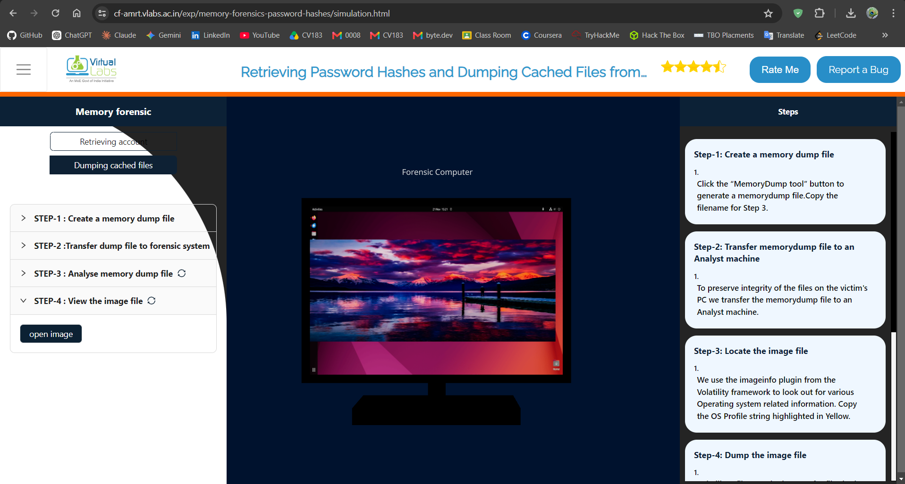
Posttest:
What are Symbol tables?
a: A table with mapping of addresses and human readable names
Is it possible to extract every file present on a file system from a memory dump?
b: no
What type of files are typically recovered during memory forensics?
b: Files that were actively loaded into memory
Which tool is commonly used to analyze memory dumps?
b: Volatility
Why might cached files appear in memory dumps?
b: Because they were recently accessed and kept in memory for performance
Which memory region typically stores process-related data like stack, heap, and code segments?
b: User space memory
In memory forensics, what is the purpose of extracting process lists?
a: To analyze active and terminated processes during the memory snapshot
Which command in Volatility is commonly used to list running processes?
a: pslist

Conclusion:
Text was successfully hidden inside an image by modifying least-significant bits and later recovered intact, confirming the LSB technique preserves visual quality while carrying a hidden payload. The second part showed how the identical technique can be repurposed offensively to smuggle a malicious URL inside an image, underlining why steganalysis is an important part of malware investigation

